THE EMMAUS NEWSLETTER Volume 16 Issue 5

Columbus Indiana Area Emmaus Community, Inc. May 2008

Letter to the Community:
The Fruit of Emmaus
What is it that makes The Walk to Emmaus so powerful? The Father with a desire to bring us back to Himself. Jesus as He so passionately intercedes for us. The Holy Spirit of God as He brings us to the full knowledge that God genuinely loves us. But how, in 72 hours, it happens time and time again, I cannot explain. It is the power of God at work. It is the fruit of Emmaus.
The Bible says we can know whether a thing is good or bad by the fruit it produces. The Emmaus Walks and the Chrysalis Flights produce incredibly good fruit. Sponsors do not sponsor just once. They continue to send people, because of the changes the Lord is able to exact in the lives of those who have experienced these events. We can look at our own lives and see how God has helped us sift through the pieces and know what needs to go and what can be used for His glory.
An Emmaus Walk does not replace anything, it brings heightened life to where we are and what we are doing now. But soon, under the direction of God, the Holy Spirit leads us to our next assignment. We grow as He strengthens us to accomplish the task He has for us. As God directs, the Spirit takes us then to our next task. On and on we go and grow in a way that teaches us to walk in faith. We grow because we are accompanied and equipped by the Holy Spirit as we go and as we need it.
The good and bad news is that we will always be stretched and challenged. I believe we all want to be contributors to the Lord’s work, but things hold us back. Part of the fruit of Emmaus is that we know if He calls us, He will equip us. Remember this statement? “He does not call the equipped, He equips the called.”
The Emmaus and Chrysalis teams are examples of Paul’s description of the Body of Christ working together. Each person working at his area to bring one part of the whole. All jobs are important, each one needed, all meshing together into a picture that none knows what it will look like when it is finished. Only God can judge the success or failure of the work.
The individual jobs on the teams teach us leadership qualities. The contribution of all the jobs is no less or no more important than the contribution of any job. All are necessary. But as we move from entry level positions to more experienced positions, we are learning new skills, new trust in God’s ability to work with broken vessels. It is not our ability He needs; it is our willingness to say, “Yes, if You will go with me.” The Spirit will go before us and prepare safe places for us to learn. He knows how frail we are. And He can produce fruit for the Father through us.
As you look to where the Lord may lead you, stay away from the words “No”, or “I can’t”. Just because you feel like you could not be a table leader, give a talk, head the kitchen team or lead a committee in your church today, means nothing. It is God who grows us. He knows how to do His work. We need to avoid telling Him what we can do before He has time to fill and equip us for what He wants us to do.
The Emmaus Walks and Chrysalis Flights teach us respect for the Body of Christ as a whole, not just a denomination. We are better altogether than we are separately. One day we will all stand on heavenly streets together as He intended, His children, His heirs with no other labels.
For now He has work for us to do. Step up and grasp the plow, He will provide the power. There are seeds to be planted and fruit to be produced.

Your fellow pilgrim, Renée Kasting, Community Lay Director
New Board Member Profile

Noel Taylor, Columbus Area Emmaus Community Walk #17, table of Mark. Barbara and I will celebrate our 31st wedding anniversary in April of this year, have two sons both of whom are grown and married, and no expectation of grandkids yet. Through God's supernatural provision of time, I'm a Bible Study Fellowship International discussion leader in the Columbus evening men's BSF class, a speaker in the Columbus Camp of Gideons International, a member of Community Church of Columbus, and your Community Events board member until the end of 2010. I'm also a chiropractic physician in private practice in Columbus, an avid recumbent bicycle rider, and a ham radio operator. I worked the past two fall men's Walks in the kitchen, and am looking forward to connecting more faces and names with each other within the Emmaus community. If you have comments or ideas regarding our monthly Gatherings, please let me know!

~~~~~~~~~~~~~~~~~~~~~~~~~~~~~~~~~~~~~~~~~~~~~~~~~~~~~~~~~~~~~~~~~~~~~~~~~~~~~~~
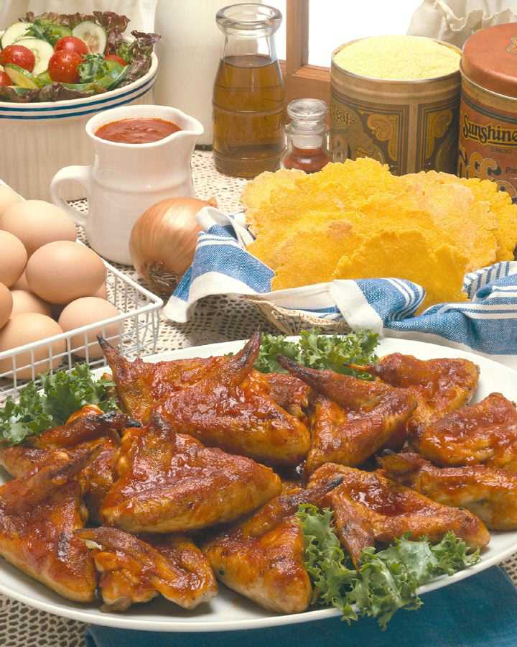
May Pitch-in/4th Day Meeting/Gathering
Friday, May 16, 2008
4th Day Meeting starts at 6 pm,
Pitch-in Dinner starts at 7 pm
St. Peter’s Lutheran Church, 719 5th St., Columbus
~~ *See location of events below in the note from Noel ~~
Everyone is invited to come! We celebrate the Lord’s great
blessings to us by welcoming the newest members of our
Community—the pilgrims from Walks #67 and #68. Sponsor’s
and pilgrims get to go first! If you were a pilgrim on these walks,
all you have to do is bring yourself! For everyone else, please bring table service and your favorite food to share. This is your chance to fellowship with old and new friends, praise the Lord, and receive Holy Communion. Child care is provided for children ages 6 and younger.

A Note from Noel Taylor, Community Events Board Member

SET-UP
A.C. Reeves needs several strong men to help with set-up for the May Gathering at St. Peters Lutheran Church in Columbus. Because the 4th Day meeting starts at 6:00 and the tables to hold food will need to be ready by then even though the Gathering itself isn't until 7:00, he needs some real heroes to come by at 5:30 to help. Please email him at venture2003@comcast.net or call his cell phone at 343-8767 if you can do this. A.C. will also need people to direct "traffic" in the building and to help handle last-minute set-up things between 6:00 and 6:30, and will need some help with tear-down after the gathering as well. If you can help with any of this, please let him know soon!

*4TH DAY MEETING ROOM
As you come in the doors from the parking lot where the receptionist desk is -- the entrance furthest from the sanctuary -- go up the stairs, turn left at the top of the stairs, and you'll find the meeting room down the hall on left just past the bathrooms.

*GATHERING LOCATION
The meal portion of the Gathering will be in the cafeteria and gymnasium at the far east end of the church. The worship portion will be in the sanctuary at the far west end of the church. There is extra parking east of the church if the south parking lot fills up.

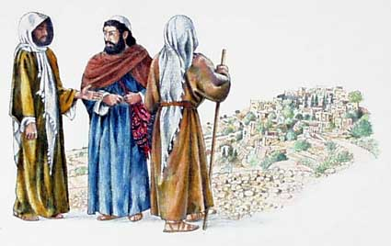

They asked each other,
"Were not our hearts
burning within us while He
talked with us on the road
and opened the
Scriptures to us?"
Luke 24:32

~~~~~~~~~~~~~~~~~~~~~~~~~~~~~~~~~~~~~~~~~~~~~~~~~~~~~~~~~~~~~~~~~~~~~~~~~~~~~~~

A Few Comments from the Pilgrims of Walks #67 and #68

The love that was shown over the past three days was amazing – This has been a wonderful experience to renew and refresh my walk – The teachings have been a tool to keep me focused – It’s my desire to make it to heaven and take as many with me as I can – It was a renewal of my spirit – At first, I thought “this is a weekend for me!” Now I see that the way the people served me is the way I should serve the Lord – I realized this weekend that I can still hear God’s voice – You can’t ever have enough fire in your heart, I intend to serve! – I’ve felt more of Jesus’ love than I have ever experienced in my life and I can’t wait to spread that love – This Walk has been so humbling, how can I put it in words? – I am so blessed that my wife is coming next week – This Walk almost overwhelmed me last night (at Candlelight) – I can’t wait to come back and help – this has been a major experience for me! – When you get older, you need to go to the eye doctor to help get your vision focused; this weekend has sharpened my focus on the Lord – This Walk taught me more about love, faith, commitment – I didn’t walk through Candlelight, I floated through it! – If everyone in the world could go through this 72 hour experience, there wouldn’t be any more wars, gas gouging prices, you name it! – I think if I could show the world a glimpse of the love that you have shown me this weekend, that would be great –I’m going to do whatever God asks me to do! – It’s almost indescribable what this Walk has meant to me – I intend to stop being a part-time Christian and be a full-time one – I like to drive a lot, and I intend to give the steering wheel to God – These 3 days have been incredible – This has been a life-changing event, my plan is to be a better, more willing witness for God.

~~~~~~~~~~~~~~~~~~~~~~~~~~~~~~~~~~~~~~~~~~~~~~~~~~~~~~~~~~~~~~~~~~

This is what I needed; a renewed intimacy with my Lord – It’s taught me that there are people out there that really care for me – I’ve also learned that it’s okay to let people wait on me – I came to Emmaus with questions, and I got some answers I wasn’t even looking for – I’m not sure what I’m going to do but I’m sure that whatever He tells me to do, I’m going to listen and He will send me the support – I realize that I actually meant something to somebody this weekend and I never thought I did – This weekend has touched me in ways I cannot explain – I will listen and I will obey and I will trust – It’s amazing to see so many Christians in one place (Candlelight), can you imagine what heaven will look like? – God is full of surprises – I love you guys – When I felt my bed shaking Friday morning I thought God was really talking to me and that was during the hours we couldn’t say anything to each other! – This weekend has been so incredibly touching – I’ve learned that God is the #1 priority in my life – Satan tried really hard to make sure I wasn’t here this weekend – I needed to know God’s love and see Jesus’ face, and I saw that last night – When I got to the end of Candlelight, I can honestly say that I felt the presence of God – I’ve learned that if you smile the whole 72 hours of the weekend, you have a tremendous headache, but it’s worth it – I need to stop making excuses and realize that if Christ walks with me I can do anything – God knew the timing for me – I’m going to stop doing, doing, doing, and start loving, loving, loving! – I’m not good at showing love or receiving love, but this weekend, I have been CRUSHED with it! – What these 3 days have meant to me, WOW – God loves me no matter what! – I’ve learned a lot this weekend – it’s not about knowing about God, it’s about knowing God!

~~~~~~~~~~~~~~~~~~~~~~~~~~~~~~~~~~~~~~~~~~~~~~~~~~~~~~~~~~~~

Columbus Indiana Area Emmaus Community, Inc. Home Page:
www.columbusinemmaus.org
Emmaus Information Page (for community members):
www.columbusinemmaus.org/emmaus/members
User name: columbusemmaus password: 4thday

Dates for
Upcoming Walks
& Flights
May Gathering
4th Day Meeting/Pitch-in Dinner to Welcome New Pilgrims
Friday, May 16, 4th Day Meeting starts at 6 pm,
Pitch-in Dinner starts at 7 pm
St. Peter’s Lutheran Church, 719 5th St., Columbus
Childcare provided for ages 6 & under Dates for
Chrysalis Flights #29 & #30 | Aug 30, - Sept 1, 2008
Men’s Walk  #69 | Oct  16-19, 2008
Women’s Walk  #70 | Oct  23-26, 2008
Walks
& F
June Gathering
Friday, June 20, 7 pm,
Cornerstone Community Church,
1088 Sarasota Dr., Seymour
A—I bring drinks, snacks
Childcare provided for ages 6 & under


